StorkDB functionality query options that provide results.

Functionalities 1-3 do not take any input and therefore will provide the given results.

For functionality number 4, select 2005XODSDKXI and the big-beaked ash-owl

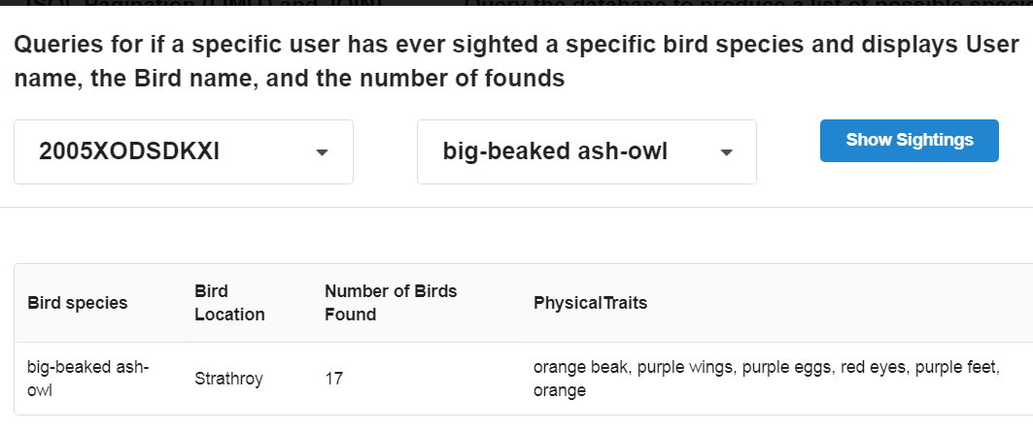

For functionality number 5, any selection will insert as long as it’s valid. A sanity check will assure the report is appropriate.

For functionality number 6, any valid combination will update the database. All invalid (leaving selections blank) will present an error.